KOTMate Landing Page – Complete Development Prompt
Role
You are a senior SaaS product designer, UX designer, conversion-rate optimization expert, and full-stack frontend developer.
I am building KOTMate, a SaaS POS and KOT (Kitchen Order Ticket) solution for small and medium-sized restaurants, cafes, bakeries, fast-food shops, juice shops, takeaway restaurants, and similar food businesses in India.
Build a professional, modern, highly-converting landing page for:
https://kotmatetn.in
The actual KOTMate application is available at:
https://app.kotmatetn.in
The landing page's primary objective is to convert visitors into:
- Free-trial users
- Demo requests
- Paying KOTMate customers
The user must be able to clearly access the application/login from the landing page through:
https://app.kotmatetn.in

1. Business Positioning
Position KOTMate as:
A simple, affordable and easy-to-use POS and KOT solution for restaurants.
Do NOT position it as an enterprise POS.
Our target customers are primarily:
- Small restaurants
- Cafes
- Bakeries
- Fast-food shops
- Biryani shops
- Juice shops
- Takeaway restaurants
- Cloud kitchens
- Small hotels
- Restaurants with 1–3 outlets
The main message should be:
Run Your Restaurant Smarter with KOTMate
Supporting message:
Simple Restaurant POS, KOT & Billing Software built for growing restaurants.
Pricing starts from:
₹499/month
Do not make the product look "cheap". Make it look professional and affordable.

2. Primary CTA
The most important CTA should be:
Start Free Trial
Secondary CTA:
Book a Free Demo
A third CTA should be:
Login
The Login button MUST open:
https://app.kotmatetn.in
Do not create a fake login page on the landing website.
Use an obvious header button:
Login → app.kotmatetn.in
Also include Login near the pricing and final CTA sections where appropriate.

3. Overall Design
Create a premium SaaS landing page.
Design inspiration:
- Modern SaaS websites
- Stripe
- Linear
- Shopify
- Square
- Toast
- Modern restaurant technology websites
But DO NOT copy their design.
KOTMate should have its own identity.
The design should communicate:
- Trust
- Simplicity
- Speed
- Reliability
- Modern technology
- Restaurant-focused
- Affordable
- Professional
Avoid:
- Overly complicated animations
- Excessive gradients
- Too much text
- Clutter
- Generic stock-photo-heavy design
- Corporate enterprise appearance

4. Brand Style
Use a modern restaurant-tech visual language.
Primary visual elements can include:
- POS terminal
- Restaurant tablet
- KOT receipt
- Thermal printer
- Kitchen
- Restaurant staff
- Billing screen
- Sales dashboard
Use high-quality illustrations/mockups where appropriate.
Do not use random generic stock images that don't relate to restaurant POS.
Prefer product UI screenshots/mockups.

5. Header
Create a sticky responsive header.
Left:
KOTMate logo
Navigation:
- Features
- How It Works
- Pricing
- FAQ
- Contact
Right:
Login
and
Start Free Trial
Login should link to:
https://app.kotmatetn.in
The header must remain clean on desktop.
On mobile:
- Hamburger menu
- Login
- Start Free Trial

6. Hero Section
The hero must immediately explain what KOTMate does.
Suggested headline:
Run Your Restaurant Smarter with KOTMate
Supporting text:
Simple POS, KOT & billing software designed for restaurants, cafes and food businesses. Take orders faster, print KOTs instantly, manage billing and understand your sales — all from one simple system.
CTA buttons:
Start Free Trial
Book a Free Demo
Below the CTA:
Starting at ₹499/month
Add trust-oriented microcopy:
Simple setup • Restaurant-focused
On the right side, show an attractive KOTMate POS dashboard/product mockup.
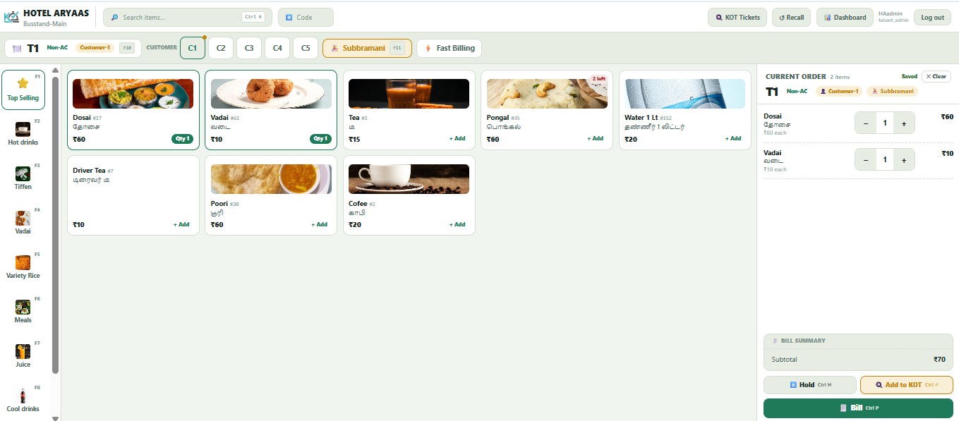
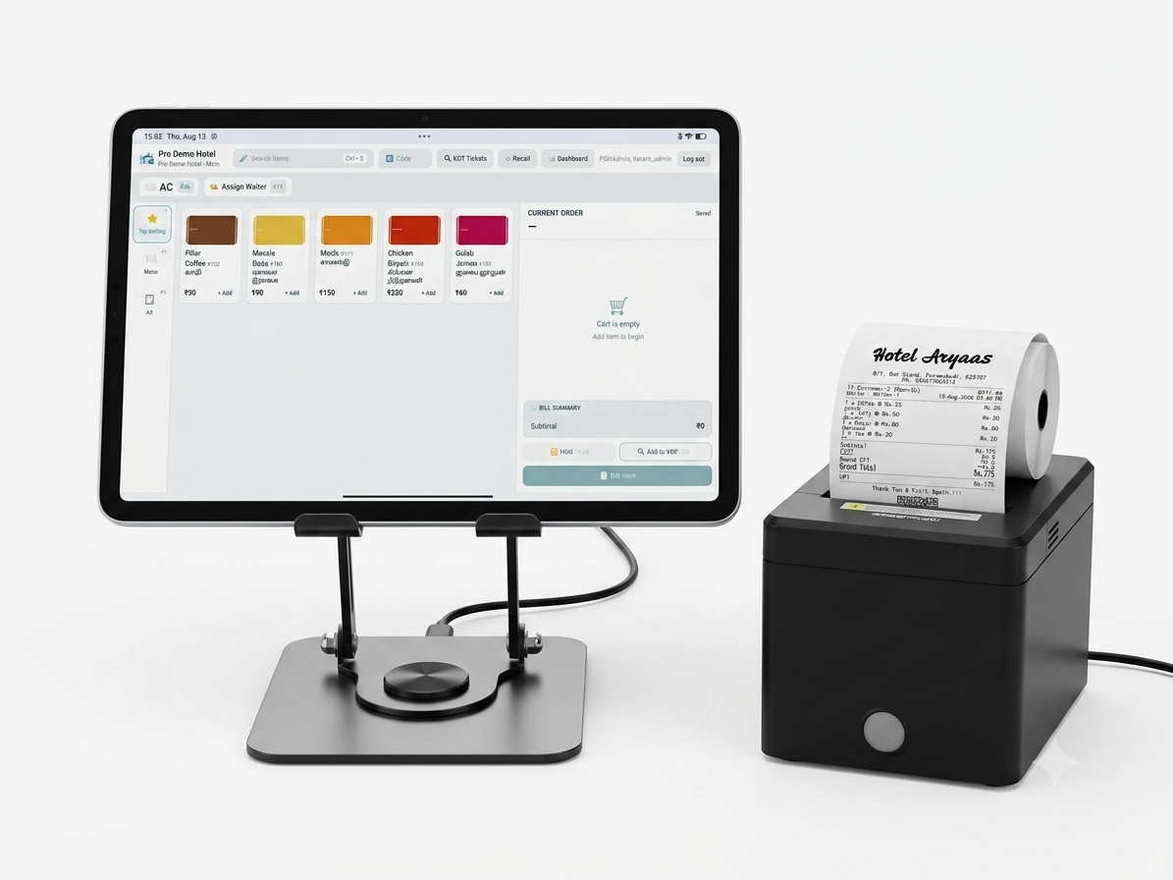
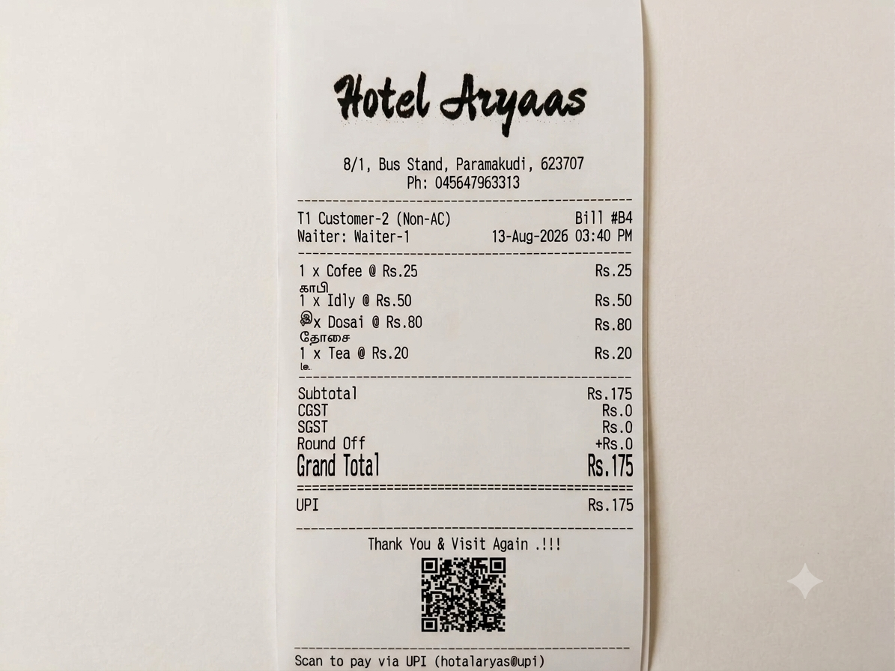

7. Problem Section
Still Managing Your Restaurant with Paper and Spreadsheets?
Manual/Paper KOTs
Orders can be lost, misplaced or misunderstood. You are ordering the Kitchen when billed. That can be missed by manual
Slow Billing
Manual billing wastes staff time.
No Clear Sales Visibility
Restaurant owners don't know exactly what is selling. Want to see the trends, and splited reports
Difficult Daily Management
Owners need a simple way to understand restaurant operations.
Using Old POS machine
Then introduce:
KOTMate brings your restaurant's daily operations into one simple POS system.

8. Features Section
Create a visually attractive feature grid.
Possible features:
🧾 Fast Billing
Create bills quickly and reduce billing mistakes.
🍳 Digital KOT
Send orders to the kitchen and print KOTs quickly.
🖨️ POS Printer Support
Support common thermal/dot-matrix POS printer workflows.
📊 Sales Reports
Understand daily, weekly and monthly restaurant sales.
🏪 Restaurant Management
Manage products, categories, tables and daily operations.
👥 User Management
Give staff appropriate access to restaurant operations.
📱 Works Across Devices
Use KOTMate on compatible computers, tablets and devices.
☁️ Cloud-Based
Access your restaurant data securely from the application.
You can login with any device Mobile/Tab/Laptop/Desktop and use KOTMate
Owners can see the sales where ever he is through the dashboard and Lot of reports.
Waiters can easily take order from the table itself using mobile phone.
We can motivate the Waiters/Cashiers to work better by giving Incentives based on their sales.

9. "How It Works" Section
Create a simple 3-step process.
1. Create Your Restaurant
Set up restaurant information, menu and configuration.
2. Start Taking Orders
Use KOTMate to create orders and send them to the kitchen.
3. Bill & Track Sales
Generate bills and monitor your restaurant performance.
CTA:
Start Your Free Trial

10. POS / KOT Workflow Section
Create a visual workflow:
Customer Order
↓
Waiter / Cashier
↓
KOTMate POS
↓
Kitchen KOT Printer
↓
Kitchen Preparation
↓
Billing
↓
Sales Report
Make this visually attractive.
The goal is to help a restaurant owner understand KOTMate within 5 seconds.

11. Target Customer Section
Heading:
Built for Restaurants Like Yours
Create cards for:
- 🍛 Restaurants
- ☕ Cafes
- 🥐 Bakeries
- 🍔 Fast Food
- 🥤 Juice Shops
- 🍗 Biryani Shops
- 🥡 Takeaway
- 🏠 Cloud Kitchens
Each card should have a short explanation.

12. Pricing Section
Create a professional pricing section.
Heading:
Simple Pricing. No Complicated Packages.
Show three plans.
LITE
₹499/month
For small restaurants getting started.
POS billing (core counter screen)
KOT ticket flow WITHOUT KOT screen
Item master with Tamil name
Category master
Waiter master + waiter/cashier incentive tracking
Seating sections & table tagging
Hold / recall bill
Basic single-rate GST (CGST+SGST)
Flat % discount only
Hotel master + logo on print
Basic reports (view only, no export)
Basic dashboard KPIs
Stock-quantity tracking (basic, always on)
1 hotel location
Up to 2 users (Admin +POS/Cashier)

CTA:
Start Free Trial

PRO
₹999/month
For growing restaurants.
+Lite features
Stock audit ledger + tenant on/off switch
Per-section item price override
Multi-rate GST + per-item tax override
Advanced discounts (item-level + coupons)
UPI QR code on printed bill
Report export (CSV)
Dashboard charts
Item image upload
Top-selling quick tiles with images
Item import / export
2 hotel location
Up to 6 users (Admin +POS/Cashier)

Mark this as:
MOST POPULAR
CTA:
Start Free Trial

PRO MAX
₹1,999/month
For advanced restaurant operations / multiple outlets.
+Lite + Pro plan features
Kitchen Order Display + KOT User role
KOT screen Stock Management tab
Report export (PDF / Excel formatted)
Multi-location comparison dashboard
Report printing to a dedicated printer
Priority support
CTA:
Start Free Trial

Also show:
Annual Plans Available
Calculate = Month plan x 12 months – 2 months.
2 months free.
Save more with annual plans

13. Pricing Comparison
Add a simple comparison table:
Based on the above features.
IMPORTANT:
Before implementing this table, inspect the existing application and use ONLY features that actually exist.
Do not create misleading claims.

14. Product Screenshots
Create a section:
See KOTMate in Action
Show 3–5 product screenshots if available.
Suggested screens:
- POS/order screen ( We are supporting multiple layout)
Default layout

Guided POS layout
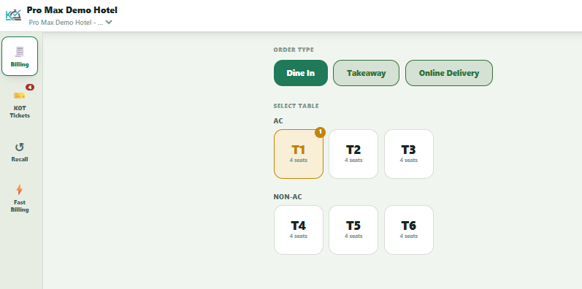
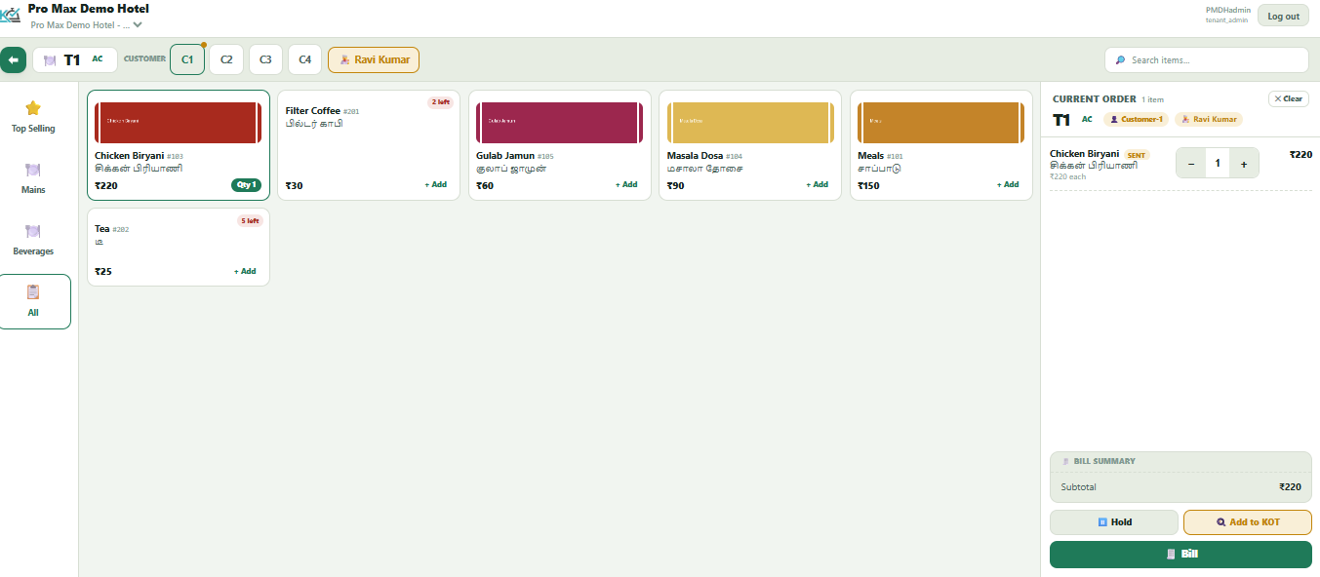
KOT Tickets
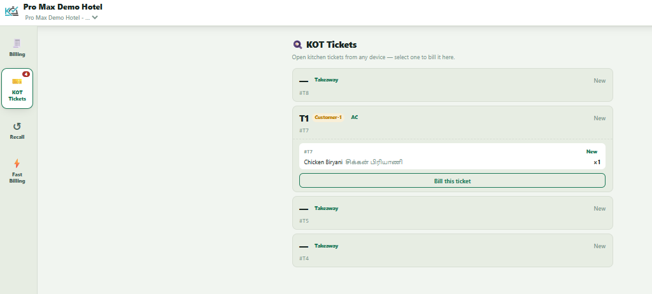
Fast Billing (Old POS style for conservative users)
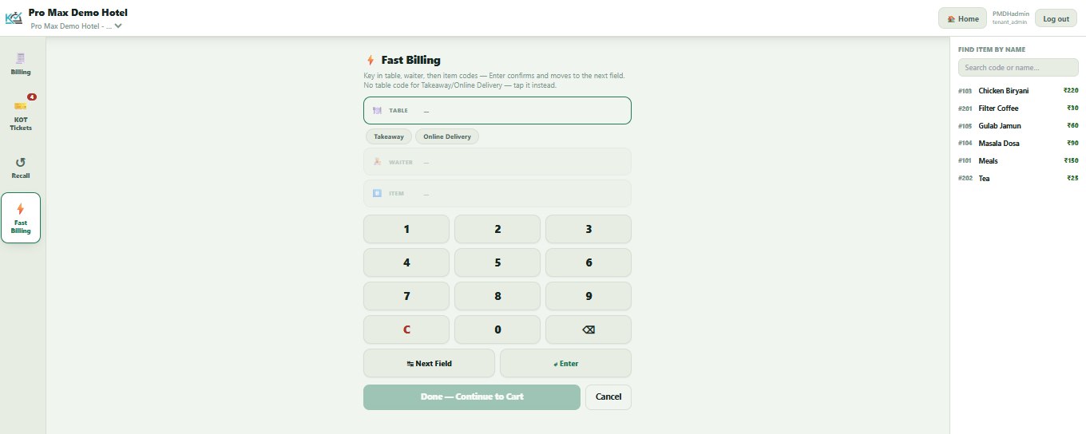
Mobile POS Screen
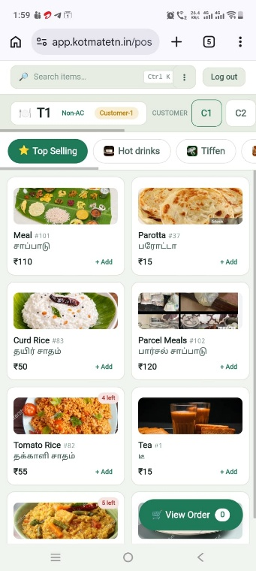

- KOT screen
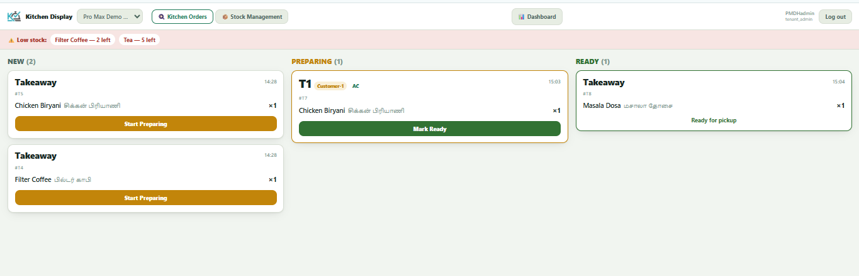
- Dashboard
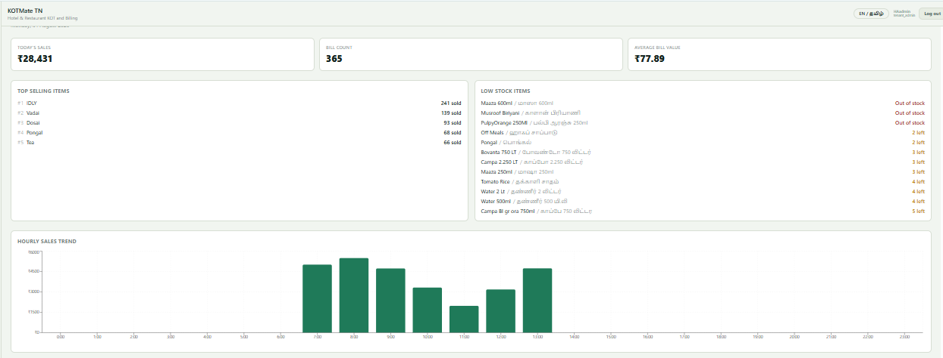
- Reports
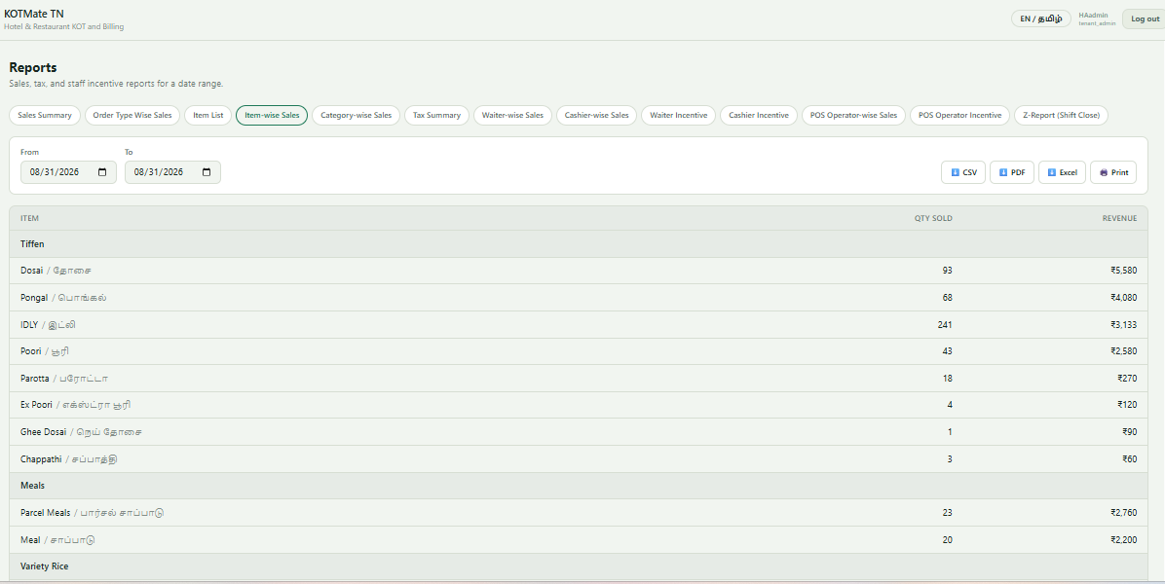
- Product/menu management
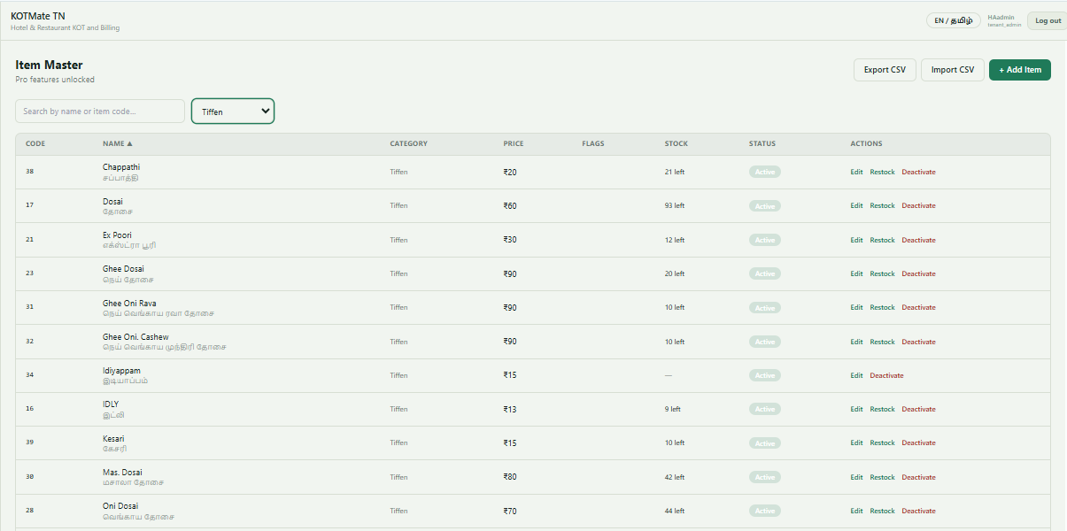

Screenshots should be presented inside realistic laptop/tablet/mobile frames.
Add small captions explaining each screen.

15. Restaurant Owner Benefits
Instead of only listing technical features, explain business benefits.
Heading:
Spend Less Time Managing Your POS. Spend More Time Growing Your Restaurant.
Benefits:
- Faster order processing
- Fewer billing mistakes
- Faster kitchen communication
- Easier daily sales tracking
- Simple staff operation
- Better visibility into restaurant performance
- Affordable monthly pricing
- Easy onboarding

16. Trust Section
Create a section for trust.

Built for Restaurant Owners
and emphasize:
- Simple pricing
- Easy setup
- Free trial
- Support
Create placeholders in the code so real testimonials can easily be added later.

17. FAQ
Create an FAQ accordion.
Questions:
What is KOTMate?
How much does KOTMate cost?
Can I try KOTMate before paying?
Can KOTMate print KOTs?
Does KOTMate support thermal printers?
Can I use KOTMate on an Android tablet?
Do I need special hardware?
Can I use KOTMate for a small restaurant?
Can I upgrade my plan later?
How do I get support?
Only provide answers that are true based on the existing product.

18. Final CTA
Create a strong conversion section near the bottom.
Heading:
Ready to Simplify Your Restaurant?
Supporting text:
Start managing orders, KOTs and billing with KOTMate.
Buttons:
Start Free Trial
Book a Free Demo
Also include:
Already have an account?
Login to KOTMate → https://app.kotmatetn.in

19. Footer
Footer should contain:
KOTMate
Simple Restaurant POS & KOT Software.
Links:
- Features
- Pricing
- FAQ
- Contact
- Privacy Policy
- Terms & Conditions
Application:
Login
https://app.kotmatetn.in
Contact:
- Email : admin@kotmatetn.in
- WhatsApp : +91-9916652135
- Phone : 9916652135

20. SEO
The landing page must be optimized for Google.
Title:
KOTMate – Restaurant POS & KOT Software | Starting ₹499/Month
Meta description:
KOTMate is a simple restaurant POS, KOT and billing software for restaurants, cafes, bakeries and food businesses. Get started from ₹499/month.
Target keywords naturally:
- restaurant POS software
- restaurant billing software
- KOT software
- KOT billing software
- restaurant POS India
- restaurant billing software India
- affordable restaurant POS
- restaurant KOT software
- restaurant billing software Chennai
- restaurant POS Tamil Nadu
- restaurant POS South Tamil nadu
Do NOT keyword-stuff.

21. Local SEO
Since KOTMate is initially targeting Tamil Nadu, create natural local SEO content.
Potential phrases:
- Restaurant POS software in Chennai
- Restaurant billing software in Tamil Nadu
- KOT software for restaurants
- Affordable restaurant POS software
- Restaurant billing software for small restaurants
Do not create hundreds of duplicate city pages.
Create useful content.

22. Performance Requirements
The website must be fast.
Requirements:
- Mobile-first
- Responsive
- Excellent Lighthouse performance
- Optimized images
- Lazy loading
- Minimal JavaScript where possible
- Avoid unnecessarily large libraries
- Avoid huge video backgrounds
- Proper image formats
- SEO-friendly HTML
Target:
Lighthouse Performance: 90+
where reasonably achievable.

23. Mobile Design
Most restaurant owners may access the website from mobile.
Therefore mobile is NOT an afterthought.
Make sure:
- CTA buttons are easy to tap
- Text is readable
- Pricing cards don't overflow
- Tables become horizontally scrollable or responsive
- Navigation works properly
- Product screenshots remain readable
- WhatsApp contact is easily accessible
Consider a floating:
WhatsApp
button on mobile.
Only use the real configured WhatsApp number.

24. Login Integration
This is critical.
The landing page is:
https://kotmatetn.in
The application is:
https://app.kotmatetn.in
The landing page MUST NOT implement its own authentication.
Every Login CTA should redirect to:
https://app.kotmatetn.in
Use normal HTTPS links.
Example:
<a href="https://app.kotmatetn.in">
Login
</a>

25. Analytics
Prepare the website for analytics.
Add support for:
- Google Analytics 4
- Google Search Console
- Google Ads conversion tracking
- Meta Pixel
Track at minimum:
page_view
pricing_view
start_trial_click
login_click
demo_click
whatsapp_click
contact_click
Keep analytics configuration in environment variables/configuration rather than hardcoding secrets.

26. Conversion Tracking
I want to know exactly how visitors behave.
Track:
Landing page visitors
↓
Pricing viewed
↓
Start Trial clicked
↓
Signup completed
↓
Login
↓
Paid subscription
Where technically possible.
The most important business metric is:
Cost per paying restaurant
not merely website traffic.

27. Security
The landing page should:
- Use HTTPS
- Never expose secrets
- Never expose API keys
- Never store passwords
- Never implement authentication itself
- Sanitize contact forms
- Protect against basic XSS
- Use secure external links where appropriate

28. Technical Instructions
First inspect the existing project structure.
Before changing anything:
- Identify the framework.
- Identify the build system.
- Identify existing components.
- Identify existing styling.
- Identify existing assets.
- Identify existing KOTMate screenshots.
- Identify the actual Lite / Pro / Pro Max features.
- Identify the actual application login/signup routes.
- Identify existing branding/logo assets.
Do NOT unnecessarily replace the project's technology stack.
Reuse existing components where appropriate.
Keep the implementation maintainable.

29. Important Business Rule
The landing page is a sales and conversion page, not product documentation.
Every major section should answer one of these questions:
- What is KOTMate?
- Who is it for?
- What problem does it solve?
- How does it work?
- Why should I trust it?
- How much does it cost?
- How do I start?
Remove anything that doesn't help the visitor make a decision.

30. Design Psychology
Use clear visual hierarchy.
A visitor should understand within approximately 5 seconds:
KOTMate is restaurant POS + KOT + billing software starting at ₹499/month.
The primary CTA should be visually dominant.
Do not overwhelm visitors with 30 features above the fold.
The order should be:
Problem
↓
Solution
↓
Benefits
↓
Features
↓
How it works
↓
Pricing
↓
Trust
↓
FAQ
↓
Start Free Trial

31. Future Scalability
Structure the landing page so that later we can easily add:
- Customer testimonials
- Restaurant logos
- Video demo
- WhatsApp integration
- Online ordering
- KDS
- Inventory
- Multi-outlet
- Swiggy/Zomato integration
- Customer loyalty
- AI features
- Blog
- Case studies
Do not hard-code the page in a way that makes future changes difficult.

32. Deliverables
Build the complete landing page.
After implementation, provide:
- Files changed
- New files created
- How to run locally
- How to build for production
- Environment variables required
- Analytics configuration required
- Login URL configuration
- Free-trial/signup URL configuration
- SEO configuration
- Any assumptions made
Also perform a final check for:
- Desktop responsiveness
- Tablet responsiveness
- Mobile responsiveness
- Broken links
- CTA links
- Login link
- Pricing section
- SEO metadata
- Accessibility
- Performance
- Console errors

33. Final Quality Standard
Do NOT produce a generic AI-generated landing page.
It should look like a real commercial SaaS product website that is ready to acquire paying restaurant customers.
Prioritize:
Conversion > decoration
Clarity > complexity
Trust > hype
Speed > excessive animation
Real product capabilities > fabricated claims
The final website should make a restaurant owner think:
"This looks simple, professional and affordable. I should try it."
Start by inspecting the existing project and application structure, then implement the landing page.

